User Dash Board:
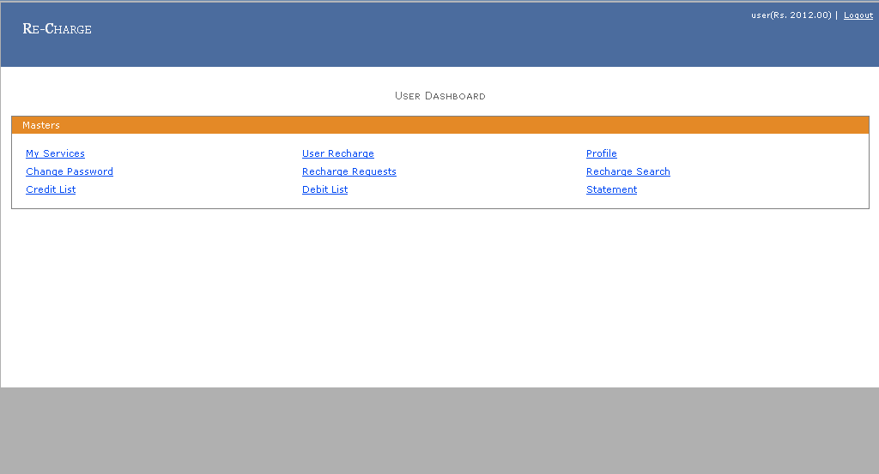
1) User Services: User Can Add Delete and Edit Service for Particular Mobile Number.
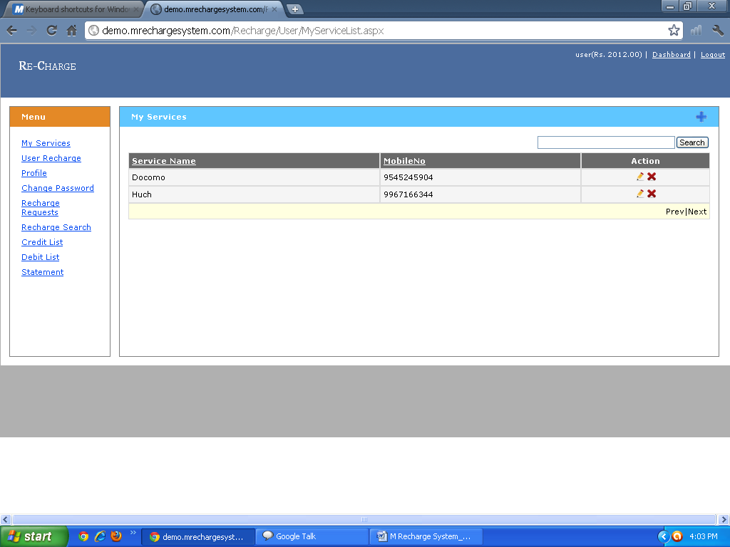
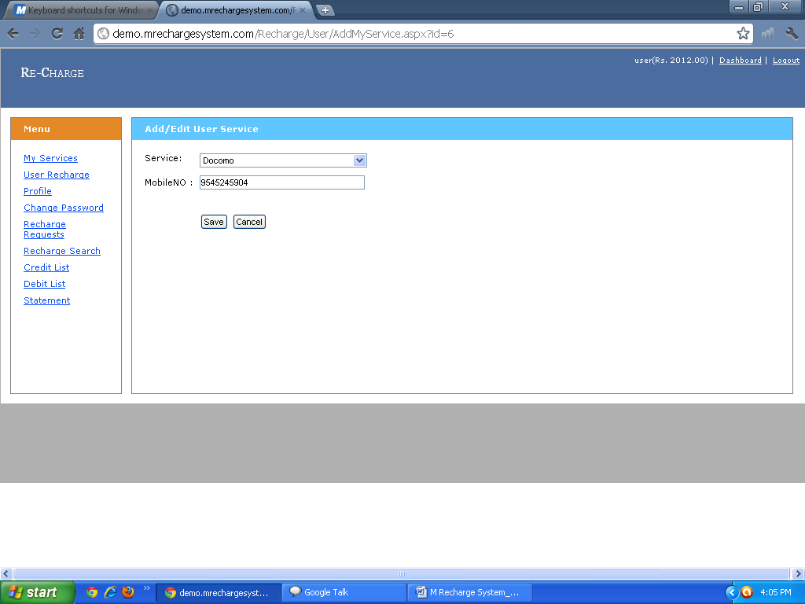
2) User Recharge: User Can Recharge on particular Mobile Number.
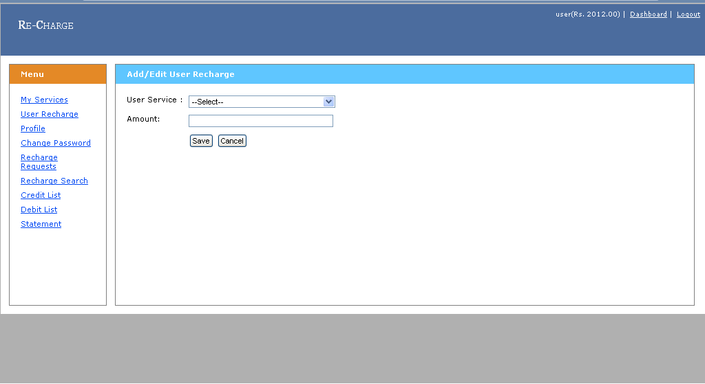
3) User Profile: User can see his Profile and User Also Update His Profile.
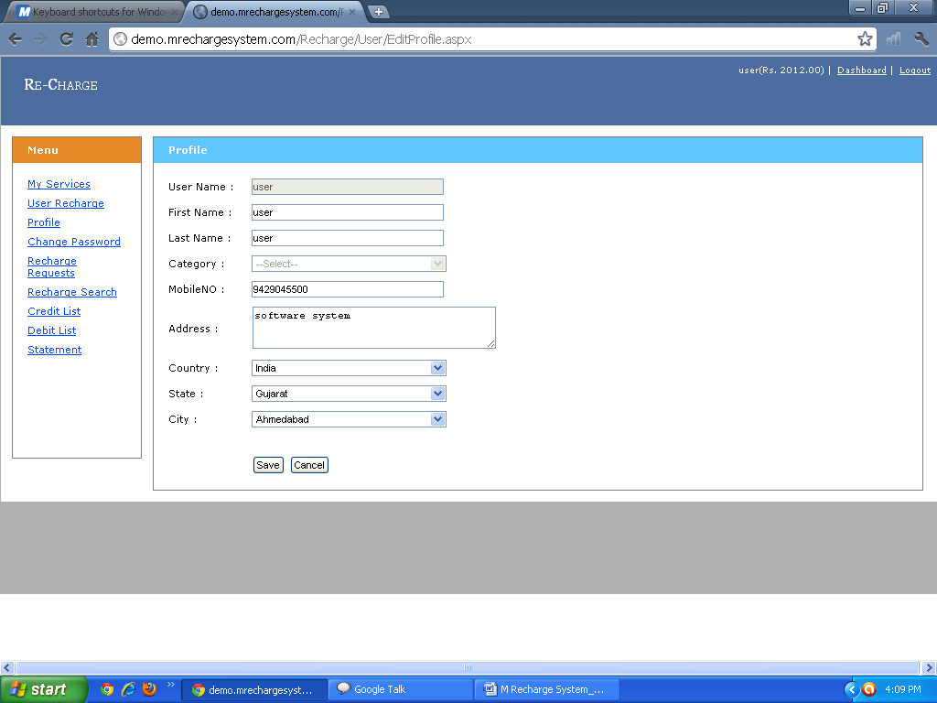
4) Change Password: User Can Change His Password Also.
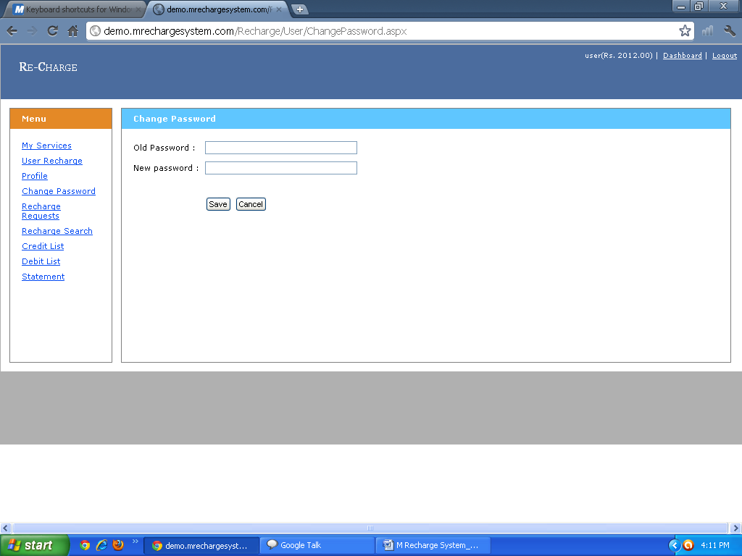
5) Recharge Request: Dealer can see how many user and Staff Member can Request for Recharge. Dealer Can See All the Information Regarding User and Staff. Dealer can find Particular User from Advance Search Option.
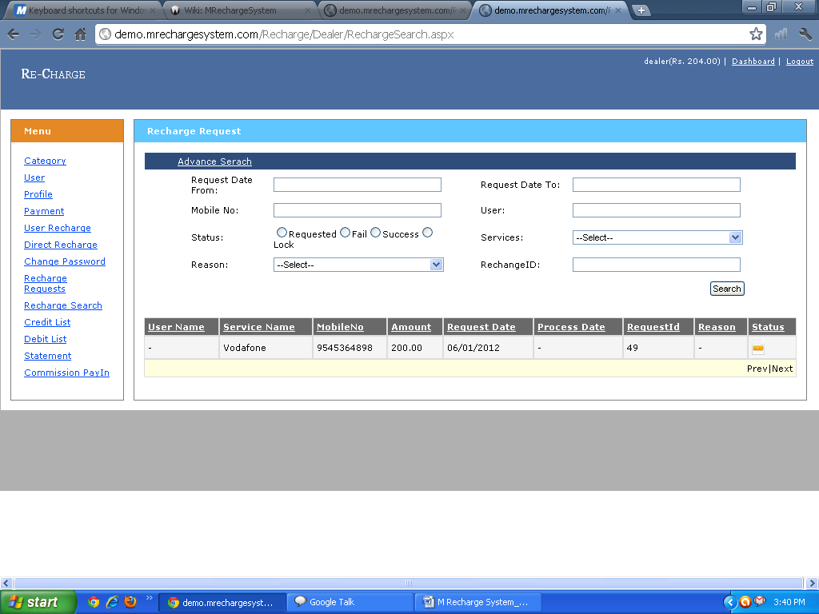 6) Credit List: User can see the Credit List and see the Transaction Details and Status and used AdvanceSearch option for Finding particular infromation.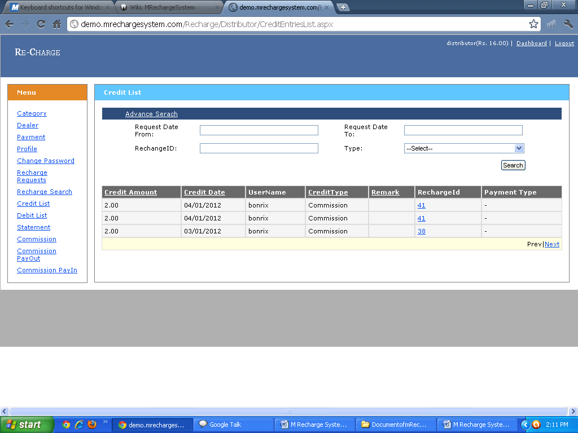

7) Debit List: user can see the Debit List and see the Transaction Details and Admin can also used Advance Serch for finding particular user .
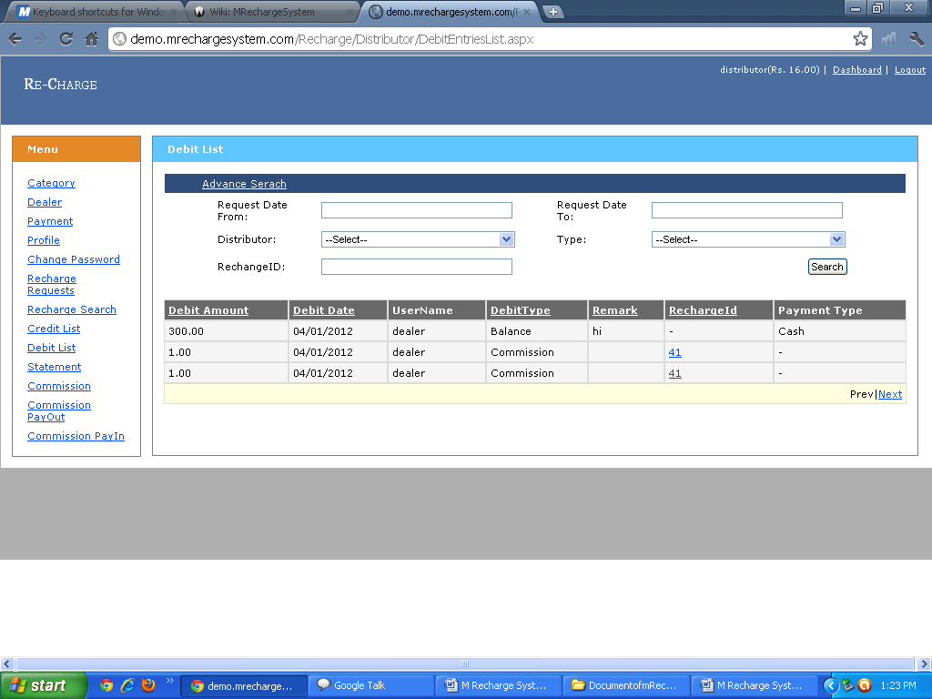

8)Statement: User can See How many and Which Type of Transcation Perfrom By User.
